STEP |  | ACTION
FILL OUT the RPQ request on this Forms link:
https://forms.osi.apps.mil/Pages/ResponsePage.aspx?id=1aCbNssCL02U_ZISzCS3jBxfol_SkBJDnfSeBSzTt-lUNkJJOFRINTU5V1hLNDFDNFRJRzZGR09FTC4u
 |  | SUBMIT the form and wait for CSCM Reed to send you a Dropbox link.
RECORD a 3-5 minute video of the RPQ you want to complete on your phone.

Criteria for the video submission:

- State what RPQ is being recorded
- State the recipe used from Professional Cooking 8th ed.
- Show Mise en Place
- Record yourself accomplishing task according to reference (Professional Cooking 8th ed.)
- Record final product

Video should show and explain technique, and final outcome of the completed RPQ.

Submit your video via Dropbox
Once your video is finished and you have received the Drobox link, then:
IF | THEN
You have Dropbox on your phone | GO TO Step 7
If you do not have Dropbox on your phone | Continue to Step 5

 | Download the Dropbox app on your phone.
CREATE a Dropbox account using the SAME civilian email as the one you used on the Form in STEP 1.

*IMPORTANT* The email address MUST BE a civilian email address, (gmail, yahoo, etc) and MUST BE the same as the one you entered in STEP 1 or the link you get will not work.
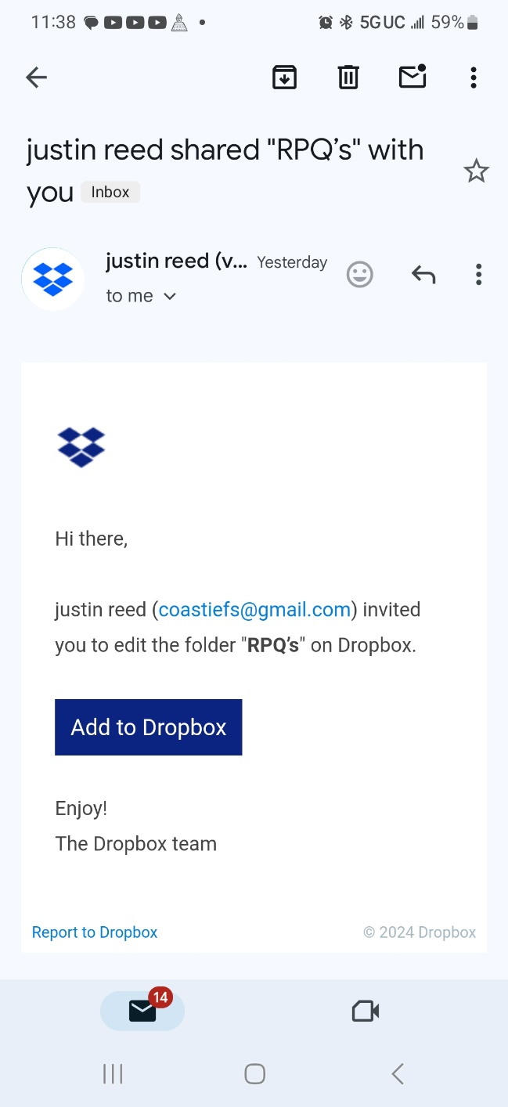
On your phone, OPEN your email app and click the hyperlink from CSCM Reed.
UPLOAD your video by clicking on the ‘Share’ button and selecting your video from your phone’s gallery or photo app.
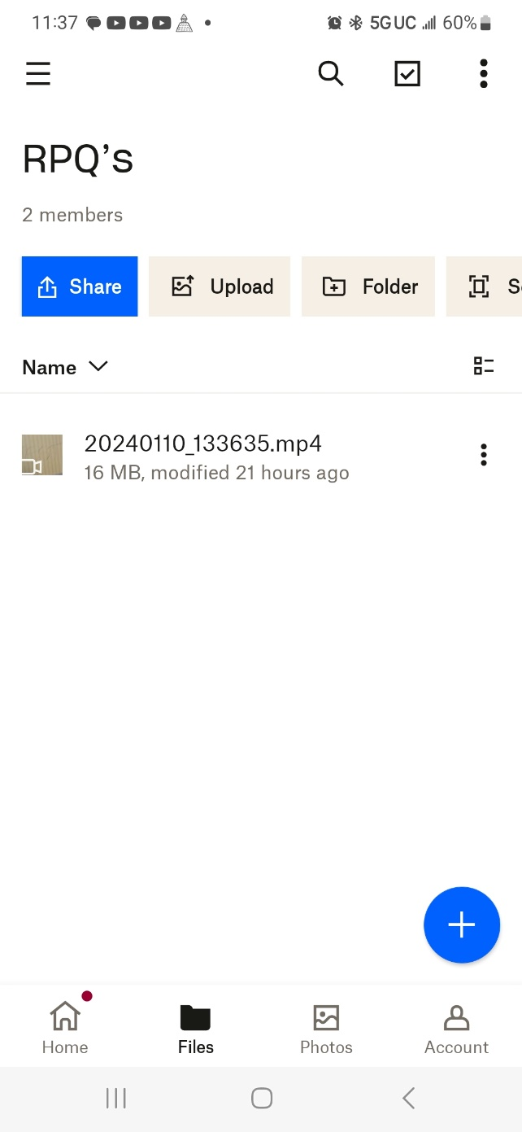
End of Job Aid

